Overall plot beatsheet:
Chapter 1: Introductions
We start knowing nothing
The photographer asks introductory questions
The characters introduce themselves
The photographer asks a series of ice breakers
Each character answers one at a time

Chapter 2: your story
The photographer reveals that all the participants of this series are mentally ill and asks them to share their diagnosis and their mental health journeys

Mel:
Mel shares that shes a paranoid schizophrenic
Mel starts the story at 12 explaining how she always knew something was off with her
She would get depressed for months on end and nobody would really knew what was happening
Her parents would leave her in her room for days on end when she was feeling this way
She showed potential as a kid being good at most things
There was never a name for it until her first episode
She was 19
It started with small things
Shadows darting in the corner of her eye
An overly active imagination
Seeing things when she closed her eyes
Its at this point she starts doing a lot of drugs
This triggers a psychotic episode
She thought drake was after her
She thought that she had figured out religion
She would see shadow men
She was struggling in school
She wouldnt leave her room
She got violent with her roommate one day
They kicked her out of school
Luckily no criminal charges
Now shes living in a flat on her parents dime
She doesn't anything all day but lie in day and watch tv and talk to friends
P asks if she truly never leaves the house
Mel reveals that the only time shes left this apartment in the last year was a 3 months in the hospital
P asks her to explain what happened
Mel was getting to it
The last episode was the worst
She had started believing that something was growing inside her abdomen
She started working up to her plan
She would practice cutting carefully along her stomach

Diego:
Diego has treatment-resistant depression
Diego has been depressed for as long as he can remember
He started this job 6 years ago and its killing him
Diego has had suicidal thoughts every night hes worked this job
He's tried everything
Hes tried all the medications
Hes tried ECT
He was catatonic for a period of time
They had to attach a cathater
That worked for a time
He was doing better
He discovered cutting at 28 when he sliced his palm open cooking

Theo:
I have Bipolar I with psychotic features
Theo explains what that means
Theo explains that he had a perfectly happy upbringing
Couldnt help but feel that something was wrong with him from a young age
Would have periods where he was crushing at everything
Sometimes he would get depressed but overall life was good
Then he came to university
He had a major psychotic episode
He thought he had super powers
He thought he was god
He was sociable active funny for a while
Until the hallucinations and the paranoia started
He thought his friends wanted to murder him
He tried to get mental health support but was unsuccesful
Therefore the episode went untreated until it ended
He crashed after the episode
Severe depression for months
He finally got help
That's when he started cutting
Pat:
Pat shares that he was a catholic growing up
Pat explains that growing up he had a very strong connection to god
Pat was fine up until he turned 20
He was in university at the time
He starts having sex
Alot of it
He starts to party and not go to church
He later started to hear god
God was angry at him
God explained to him
If he were to go to heaven he had to atone
He had to castrate himself
So one day he took the biggest kitchen knife he could find and lopped it off

Alex:
Starts at 15
She meets this boy, *****, who had just moved into the city
He was a year younger than her and her friends
Cooler too
They got really close
He moved away
They still talked everyday just over the phone
They both later in life discover that they have autism and borderline personality disorder
This brings them even closer
They are having a hard time in life
They're there for each other
Alex starts going out more and having more friends
Slowly ***** gets worse
He starts breaking down more
Alex is there for him all the time
All the time
One day alex is at a club when she misses three of his calls
She goes outside the club and callsI him back
Hes dazed confused and bleeding
Hes taken alot of pills
Alex breaksdown she tries desperately to save *****
It doesn't work and they die
Alex travels to the funeral
Alex falls into a deep depression
Alex cuts herself 526 times one day as punishment

Theresa:
Theresa tells us that shes bipolar
She was diagnosed at 26
She always knew something was wrong though
She had been a quiet odd ball growing up
loved to read on her own
She was working a good job as a secretary
That's where she met her now deceased husband
She describes him
She describes how they started dating
She then tells us of her first episode of mania
How she had to take time off work
How her husband stood by her
How she got better
Then snap again
She realized this would keep happening
That there was very little she could do to stop it from happening
She tells us that she keeps having episodes throughout her life
Her husband never left her
She has now started to experience symptoms of dementia due to repeated pschotic episodes
Shes started cutting since she found out

Chapter 3: The cutting?
The photographer asks about the first time they self harmed
They answer one at a time
The photographer asks them why they self harm
They answer one at a time
The photographer asks where they self harm
They answer one at a time
The photographer asks how long they’ve self harmed
They answer one at a time
The photographer asks how they self harm
They answer one at a time
Some object to this particular question
The photographer asks if they still self harm
All but theresa say yes

Chapter 4: why were really here

You find out that all the characters are planning on killing themselves
This interview is their final message to the world
The interviewer asks if they have ever attempted before
The interviewer asks why they want to die
They answer one at a time
The interviewer asks if there is anything they want to say
They answer one at a time
At this point is the only choice in the game
Either convince them against it
Or understand their reasoning and accept that they will do it
Mel Good ending
That potential she showed when she was young is still there
Apologise for her parents leaving her to deal with her depression alone at such a young age
The title of the game changes based on how many you save

Green sections appear as black screens with questions like in old black and white movies
Black sections appear as the respective scene for the specified character
Characters beatsheet Chapter 1:
Mel:
Introduces her self as an unemployed hikimori
Photographer asks what that means
Explanation
Photographer asks how old they are
Mel says 22
Photographer remarks that shes awfully young
Mel says its a matter of perspective
The photographer says hes gonna start with a rapid fire icebreaker questionnaire
The Photographer asks what their favourite meal is
Mel says chicken strips and rice with tabasco
The photographer asks what their favourite cloud is
Mel says the wispy kind
The photographer remarks that those are called cirrus clouds and that theyre primarily made of ice crystals
The photographer asks if they would put lettuce on a hotdog
Mel remarks that that is disgusting and mentions shes a picky eater and wont even eat hotdog, and that she subsists primarily on chicken strips
The photographer asks if they take dancing seriously
Mel says she tries to have fun and that requires that you don't really take it seriously, she only dances when shes alone
The photographer asks how they feel about graffiti
Mel likes graffiti and thinks its art. She would like to do it but doesn't leave the house
The photographer asks how many seasons their favourite show is
6 season- community
The photographer asks if they ever had a musical phase
Mel used to play the piano as a kid but never really pursued it
The Photographer asks if they post on social media or just lurk
Definitely just lurk
The photographer asks if they dream and if so do they have nightmares
Sleeps very soundly for most of the day
The photographer asks what age they think would be the best in their lives
Mel says 12 because that's when she had the most friends
The photographer asks how many hours of sleep they get
14 to 16
The photographer asks what their saddest song is
The moon or I felt your shape by the microphones
The photographer asks if they ever have a fantasy of running away somewhere far
and leaving everything behind
Where would they go, it would be the same everywhere
The photographer asks if they see images in their head
Mel says she sees her memories replay in her head
The photographer asks if they believe in an objective reality
Mel says that theres no such thing as an objective reality, that reality is shaped by people perception.
The photographer asks how often they ask questions
Not often, in fact she doesn't speak much, this is the most shes spoken to someone in a year

Diego:
Diego introduces himself as an auditor and salary man (derogatory)
Photographer asks how old they are
Diego says 32
The photographer says hes gonna start with a rapid fire icebreaker questionnaire
The Photographer asks what their favourite meal is
Pho from the vietnamese place around his office
The photographer asks what their favourite cloud is
I wanna say the fluffy ones?
The photographer asks if they would put lettuce on a hotdog
Diego doesn't see anything wrong with that if youre into that sort of thing
The photographer asks if they take dancing seriously
Diego doesn't dance hes too busy at the office to go to night clubs
The photographer asks how they feel about graffiti
Diego isnt a fan, mentions how he doesn't like the graffiti around his office neighbourhood
The photographer asks how many seasons their favourite show is
Friends 10 seasons
The photographer asks if they ever had a musical phase
Diego was a theatre kid growing up and sang in musicals
The Photographer asks if they post on social media or just lurk
Diego occasionally posts
The photographer asks if they dream and if so do they have nightmares
Diego doesn't dream just blackness
The photographer asks what age they think would be the best in their lives
45 he could have saved enough money to move to malaysia
The photographer asks how many hours of sleep they get
6 at best
The photographer asks what their saddest song is
Diego is thrown back by this question
He thinks
He says Wasting my Young years by london grammar
The photographer asks if they ever have a fantasy of running away somewhere far and leaving everything behind
More about malaysia
The photographer asks if they see images in their head
They day dream, where they usually see what happens
The photographer asks if they believe in an objective reality
Yeah i would say so
The photographer asks how often they ask questions
All the time for work not much outside that

Theo:
Photographer asks how old they are
Theo says 19
The photographer remarks that he was the only one he had qualms including due to his age
Theo says he knows and is glad to be included
The photographer says hes gonna start with a rapid fire icebreaker questionnaire
The Photographer asks what their favourite meal is
Indomie ramen and a little lime
The photographer asks what their favourite cloud is
Theos a big fan of big thunder clouds but only from far away
The photographer asks if they would put lettuce on a hotdog
Theo objects and says it doesn't go with ketchup, which is essential on a hotdog
The photographer asks if they take dancing seriously
Theo says he doesn't really dance
The photographer asks how they feel about graffiti
Theo says he loves graffiti and used to do it all the time
The photographer asks how many seasons their favourite show is
Shameless, 11 seasons
The photographer asks if they ever had a musical phase
Plays guitar
The Photographer asks if they post on social media or just lurk
Definitely a lurker
The photographer asks if they dream and if so do they have nightmares
Theo smokes too much weed to dream
The photographer asks what age they think would be the best in their lives
Must be 65 when youre retired and can just read all day
The photographer asks how many hours of sleep they get
A decent 9 or 10
The photographer asks what their saddest song is
Car seat headrest I know that im asleep I hope that youre awake
The photographer asks if they ever have a fantasy of running away somewhere far and leaving everything behind
He says sometimes he imagines going somewhere far one day without telling anyone
The photographer asks if they see images in their head
They see things outside their head
The photographer asks if they believe in an objective reality
No everything is subjective
The photographer asks how often they ask questions
Not enough prefers to say quiet to not ask stupid questions

Pat:
Photographer asks how old they are
Pat says 23
The photographer says hes gonna start with a rapid fire icebreaker questionnaire
The Photographer asks what their favourite meal is
Anything but hospital food hes not too picky

The photographer asks what their favourite cloud is
Streaks in the sky
The photographer asks if they would put lettuce on a hotdog
Yeah no problem
The photographer asks if they take dancing seriously
Pat doesn't dance
The photographer asks how they feel about graffiti
Pat thinks some of it is art like cool text doesn't like scribbles
The photographer asks how many seasons their favourite show is
Doctor who 26 seasons
The photographer asks if they ever had a musical phase
Pat has always been more interested in the visual arts
The Photographer asks if they post on social media or just lurk
Pat doesn't even have a phone
The photographer asks if they dream and if so do they have nightmares
Pat dreams lucidly
The photographer asks what age they think would be the best in their lives
Pat says 45 still young enough to enjoy life old enough to have your shit together
The photographer asks how many hours of sleep they get
12 hours nothing to do but sleep in the ward
The photographer asks what their saddest song is
Nutshell - Alice in Chains
The photographer asks if they ever have a fantasy of running away somewhere far and leaving everything behind
Would like to get out after the ward
The photographer asks if they see images in their head
Pat is a schizophrenic and sees things
The photographer asks if they believe in an objective reality
He cant reconcile that with his illness
The photographer asks how often they ask questions
Always

Alex:
Photographer asks how old they are
Alex says 27
The photographer says hes gonna start with a rapid fire icebreaker questionnaire
The Photographer asks what their favourite meal is
Alex says ice cream
The photographer asks what their favourite cloud is
The ones that look like sheets in the sky
The photographer asks if they would put lettuce on a hotdog
Alex says she always does
This is the first time P has heard someone admit that
The photographer asks if they take dancing seriously
Alex hasnt danced since the incident
The photographer asks how they feel about graffiti
Alex used to graffiti with her best friend
The photographer asks how many seasons their favourite show is
2 seasons Andor
The photographer asks if they ever had a musical phase
Alex used to be in a band in middle school
The Photographer asks if they post on social media or just lurk
Alex used to post quite frequently
The photographer asks if they dream and if so do they have nightmares
Alex has nightmares every night
The photographer asks what age they think would be the best in their lives
Alex had the most fun in her early 20s
The photographer asks how many hours of sleep they get
A solid 8 but in bursts of 4 or 5 hours
The photographer asks what their saddest song is
Into My Arms - Nick Cave and the Bad Seeds
The photographer asks if they ever have a fantasy of running away somewhere far and leaving everything behind
She used to but not anymore
The photographer asks if they see images in their head
Yeah she sees her friend sometimes in her head
The photographer asks if they believe in an objective reality
Hopes there are alternate universes
The photographer asks how often they ask questions
Alex used to ask questions all the time

Theresa:
Photographer asks how old they are
Theresa says 68
The photographer says hes gonna start with a rapid fire icebreaker questionnaire
The Photographer asks what their favourite meal is
hot tomato soup and bread
The photographer asks what their favourite cloud is
Theresa remarks that that's a nice question
She says cirrus stratus
The photographer says someone had already said that but he had forgotten what it was called
The photographer asks if they would put lettuce on a hotdog
Theresa doesn't eat hotdogs
The photographer asks if they take dancing seriously
Theresa loves dancing and takes it very serious
The photographer asks how they feel about graffiti
Theresa doesn't like it
The photographer asks how many seasons their favourite show is
Downton Abbey 6 seasons
The photographer asks if they ever had a musical phase
Theresa still plays the piano
The Photographer asks if they post on social media or just lurk
Theresa doesn't know what that means
The photographer asks if they dream and if so do they have nightmares
Theresa dreams sometimes of a family
The photographer asks what age they think would be the best in their lives
Theresa enjoys her 70’s
The photographer asks how many hours of sleep they get
Theresa gets 5 or 6 hours of sleep a night
The photographer asks what their saddest song is
I fall in love so easily Chet Baker
The photographer asks if they ever have a fantasy of running away somewhere far and leaving everything behind
Theresa feels too old for that
The photographer asks if they see images in their head
Theresa used have a very active imagination that faded with age
The photographer asks if they believe in an objective reality
Theresa believes that there is an objective reality that we subjectively experience
The photographer asks how often they ask questions
Theresa says she asks plenty of questions

Photographer (universal) beats:
Photographer asks how old they are
The photographer says hes gonna start with a rapid fire icebreaker questionnaire
The Photographer asks what their favourite meal is
The photographer asks what their favourite cloud is
The photographer asks if they would put lettuce on a hotdog
The photographer asks if they take dancing seriously
The photographer asks how they feel about graffiti
The photographer asks how many seasons their favourite show is
The photographer asks if they ever had a musical phase
The Photographer asks if they post on social media or just lurk
The photographer asks if they dream and if so do they have nightmares
The photographer asks what age they think would be the best in their lives
The photographer asks how many hours of sleep they get
The photographer asks what their saddest song is
The photographer asks if they ever have a fantasy of running away somewhere far and leaving everything behind
The photographer asks if they see images in their head
The photographer asks if they believe in an objective reality
The photographer asks how often they ask questions

Starting Text:
Each shown individually
This is a series of interviews I conducted in fall 2026
I have catalogued these interviews in the form of a game
Your role in this game is to be an interviewer
The role of an interviewer is to lead the conversation and listen.
Remember that you are only an interviewer
Nothing you do will change this story

Chapters:
Each bolded line is text infront of a black screen with a ding sound effect when it first appears
When the character is speaking they are speaking in their own environment.
{options} tags indicate a point in the script where the user selects ONE of the options and moves on
Redtags are placeholder scenes to be marked with place holder and the scene id
Blue text appears non traditionally (Not in the bottom left) and instead takes up more screen space and is placed over the scene in a way that fills the negative space creatively
Introductions:
P:
Let’s get started
Why don't you start with your name, your age, and your occupation?
Mel:
Hi, I’m Mel, I'm 23…
P: That's awfully young.
Mel: That’s a matter of perspective.
P: and what is it that you do
Mel:
I’m an unemployed hikikomori
P: a hakuku what
Mel: I don't leave my apartment
Diego:
Hey, I’m Diego, I'm 32, and I’m product manager
Basically just a salary man
Theo:
Yo, it's Theo, I'm 19 and I'm a college student and a dishwasher on the weekends
P: We necessarily have younger people because the population of this series is young
But you were the only one i had objections with
You know including you in the series
Theo:
No I’m glad you did
I think it's important
Pat:
I’m Pat, I'm 22, and I don't really do anything since I've moved into the hospital
Alex:
Hey, I’m Alex, and I’m 27
Theresa:
Hello, I’m Theresa. I'm 56 years old, and I’m a retired secretary.
P:
So I usually find that people don't like talking about what we're gonna be talking about
Especially with strangers
So I wanna start with some icebreakers
You know, just some questions before we get into the real…
Meat and potatoes
Theo:
Bit odd to call it meat and potatoes
But go on
P:
What is your go-to meal?
Mel:
Chicken Strips, rice, and Tabasco.
Pretty plain but its what I like.
Diego:
There’s place around the corner,
Pho Pasteur, it's called
Great Pho
Theo:
-shot of bowl of noodles over a white skybox-(Scene ID:cutaways/ramen)
Oh let me put you on
You take an Indomie packet
Indomie is this indonesian brand of instant noodles
Anyway you take the indomie and you crush it up
Add just enough water to cover the top
Leave uncovered and then add a little lime
And youve got the best noodles on the planet
Pat:
I’m not too picky
Anything but this fucking hospital food
Alex:
Im gonna be a bit extra here
Ice cream
Theresa:
Hmm
HMMM
AH
Hot tomato soup and a nice slice of toasted sour dough bread

What is your favourite type of cloud?
In this section photos of the clouds show up instead of the usual scenes
cloud photos can be found in photos/clouds/{charname}.jpg
Mel:
You know those wispy ones really high up?
P:
Those are called cirrus clouds
They're the highest clouds and are made up of ice crystals mainly
Mel:
That's cool, I guess?
Deigo:
I don't know
The fluffy ones I guess
Sorry, that's just something I don't really care about.
Theo:
Oooh, good question,
I love a big plume-y rain cloud
I love the rain in general
Pat: I love the streaky clouds
That cover the whole sky
Alex:
I love one big grey sky
A little drizzle i perfect too
Theresa:
I love a clear day
A perfectly blue sky
Nothing better

Would you put lettuce on a hot dog?
Mel:
That sounds so gross.
{options}
[option 1]
P: Why's that?
Mel: I’m a pretty picky eater, so I don't really do green.
[option 2]
P: What do you eat then, other than chicken strips and rice?
Mel: I literally don't eat anything else
I have it for breakfast, lunch, and dinner
Well I only eat once per day but you get my point.
Diego:
Sure, if you're into that sort of thing
I don't judge
Theo:
Nah no way
Doesn't go with ketchup
Ketchup's an essential condiment for a hotdog
Pat:
Eh I don't really see anything wrong with it
Wouldnt put it on my hotdog
Alex:
Oh yeah always
People think im strange for it
Then again, my favourite food is ice cream
P: you’re the first person I met who puts lettuce on a hotdog
That's pretty special
Theresa:
I don't put anything on hotdogs
But that's because i don't eat hot dogs

Do you take dancing seriously?
Mel:
I don't think so. I try to have fun and that requires me not to take it so seriously
But i guess im serious about my unseriousness…
So do with that what you will
Diego:
I don't really dance
Its not because I can’t or I’m against it or something
I just spend most of my weekends at the office
Theo:
I’m too cool for dancing
Maybe too hot too
Pat:
I don't dance
Alex:
I used to dance
I don't any more
After you know…
P: We’ll get into that soon enough
Theresa:
Oh dead serious
I love dancing
I used to do flamenco when these hips were still real

How do you feel about graffiti?
Mel:
Well its art ofcourse
Id love to do something like that
I guess i could graffiti the walls but that's no fun
Diego:
Oh, not a fan
I find that most of the time it's just some garbage tag
Just look around the neighbourhood
Theo:
Hell yeah, man,
I used to do that all the time back in high school
Don't really anymore
{options}
[option 1]
P: Why is that?
Theo:
Because I get charged as an adult now, silly
[option 2]
P: What kinda stuff did you throw up?
Theo:
Tags mostly
Pat: Oh, I hate tags
But if it's a cool artwork, I approve
Alex:
Yeah, I used to graffiti all the time
Theresa:
Not a fan
I guess if I was younger, I wouldn't mind so much

How many seasons is your favourite show?
Mel:
6 seasons… didn’t really like the last two
Community is what it was called
Diego:
Friends, 10 seasons
It's pretty mindless, but it keeps me going
Theo:
Shameless…
11 seasons
Pat: Doctor Who, 26 seasons
It’s all I watch in here basically
Alex:
2 seasons, Andor
P: Short and sweet
That makes sense
Theresa:
Oh sadly too short
6 seasons, its called Downton Abbey

Have you ever had a musical phase?
Mel:
I used to play the piano as a kid
My mom would take me to these lessons
I never really enjoyed it
I couldn't figure out how to move my hands independently, so I never got to play the stuff I wanted to
Diego:
Yeah, actually…
I was a theatre kid growing up
P: What kind of plays did you do?
Just silly middle school stuff
I did The Addams Family once
I played Gomez
Singing and dancing and all that
Theo:
I play the guitar
Try to anyway
Sold it though
Pat:
Nah, I’ve always been more interested in the visual arts
Used to paint before I came here
Alex:
Yeah I used to be in a band in Middle School
The Gob Knoblins
Such a stupid fucking name
It was my friend *****’s idea
Theresa:
I still play the piano whenever i get the chance
Although im not as good as i once was

Do you post on social media, or just lurk?
Mel:
Post! Oh god no, I just scroll reels all day.
Diego:
The occasional story post, yeah
Theo:
All the time
I’m killing it on there
Pat:
I don't even have a phone
Alex:
Yeah, I used to post stories all the time
I'd curate little posts too every now and then
Theresa:
I don't know what lurk means
P: You know, like just look at people's posts
Theresa:
Oh no I post pictures of family gatherings and such

How many hours of sleep do you get?
Mel:
14
Sometimes 16
I like sleeping through most of the day and waking up at around 2:30
{options}
[option 1]
P: Whys that?
Mel: At around 4:30
-shot of silhouette of houses and a blue background-(Scene ID:cutaways/bluehour)

Still a ways from sunset
Theres an hour
That's blue
No one is awake at this time, not the degenerates or the early risers
Its just me
[option 2]
-still in Mel's place-
P: Seems a bit excessive, no?
Mel:
Again, that's a matter of opinion
Diego:
Ha, I get 6 at best
Sometimes 4 if it's crunch season
Theo:
A decent 9 or 10
All my classes are later on in the day
Pat:
I sleep a good twelve hours
They give you some pretty heavy stuff to help you sleep
And its all there is to do around here
Unless you wanna do the same 3 puzzles over and over
Alex:
I sleep weird
I get like 8 9 hours
But in spurts of 4 or 5 hours
Theresa:
Not irregular for a woman my age
5 or 6

Do you dream? Do you have nightmares?
Mel:
No, not really. I sleep a lot, so maybe that's why
Diego:
Pure black, that's all I see
Theo:
No way jose
Smoke too much for that
P:smoke what
Theo: The carts bro
Like disposable weed pens
Pat:
-shot of lunar surface-(Scene ID: cutaways/moon)
I have pretty vivid dreams
I’ve been having this recurring one
Im on the moon
And theres this well
I jump in the well
And i wake up every time
Just before i hit the bottom
Alex:
Nightmares every time i sleep
Its why i sleep so short
I usually jolt awake when it gets to intense
As you can tell…
This causes me alot of anxiety
Its crazy
{options}
[option 1]
P: what kinda nightmares?
Alex: Oh you know the usual stuff
A lot about *****
A lot about whats to come
P: youre afraid of whats to come?
Alex: Shouldn't I be
[option 2]
P: I’m sorry, that sounds horrible
Alex: It's okay; it's not all bad
I’m unfazed by the most absurd things
That's a perk
Theresa:
I dream of my family sometimes
I don't see them much, so they show up in my dreams
Grandmotherhood is weird like that

What age do you think was or will be the happiest?
Mel:
12 I think
I had a lot of friends back then
P: you don't anymore?
Mel: Just the one
His name is Andy
Lives in a different country though so we just talk on the phone
That's what I do with most of my day.
Diego: the way I see it if i could just make it to 45
Then i would have enough saved
To go back home
And enjoy the low cost of living haha
Theo:
Oh gotta be like 65/70
That's the age where all you get to do
Is take downers and read
Pat: hmm
45 i reckon
Old enough to have your shit together
Youndg enough to enjoy your body still
Yeah 45
Alex:
Oh, I had a lot of fun in my early twenties
Its gotta be that
Theresa:
You know im enjoying my 50s
Its peaceful
It feels like a conclusion

What is your saddest song recommendation?
Mel:
Oh easy,[hyperlink to song starts] The Moon by The Microphones [hyper link end]
Actually maybe its [hyperlink to song start] The Moon by The Microphones [hyper link end]
Diego:
That’s a bit on the nose, isn’t it
Hmm lets see
Id say [hyperlink to song start] wasting my young years by london grammar [hyper link end]
Diego:
I was just listening to it this morning
its [hyperlink to song start] Car seat headrest I know that im asleep I hope that youre awake[hyper link end]
Pat: [hyperlink to song start] Alice in Chains, nutshell[hyper link end]
Alex: Oh i could cry at the thought of this song
[hyperlink to song start]Into my arms, nick cave[hyper link end]
Theresa:
The most beautiful voice youll ever hear is in this song
It's [hyperlink start] Chet Baker I fall in love to easily [hyperlink end]
Do you ever fantasise about running away somewhere far and leaving everything behind?
Mel:
What would be the point
I’d be an unemployed hikikomori anywhere in the world
Diego:
Yeah, of course, sometimes I think about moving back home
{options}
[option 1]
P: Where's home
Diego: somewhere far away
There's a lot of nice beaches
Things are relatively cheap
Its always sunny
[option 2]
Diego:
Well, there's a reason I live here and not there
Lets just say that
Theo:
Oh I would love to disappear one day
Just vanish without telling anyone
Move into a cabin by the lake in the woods
That's the life
Pat:
Yeah I think that's my only option
Start somewhere new after the hospital
Do it right this time
Alex:
I used to
I wanted to run away somewhere when i was younger
Even had it all planned out
I was gonna hit all the national parks on the way
P: what happened to the plan
Alex: The person I was gonna do it with killed themselves
Oh
I’m sorry
Let’s move on
Theresa:
Oh, I'm too old for that
And my family
No i couldnt do that
P: strange
Theresa:
What?
P: Nothing.
Do you see images or things in your head?
Mel:
Sometimes I see my memories really vividly in my head
Does that count?
Diego:
I day dream a lot and those can get pretty dissociative
Almost like im in there you know
Theo:
Nah cant even put an apple in my minds eye
P: Sorry
Pat:
I’m a schizophrenic
So I see a lot
All the time
Alex:
Yeah sometimes i see *****
Its weird
Its good but its weird
P: its good?
Alex: Yeah, it's good
Theresa:
I have a very active imagination
Most of the day is spent in a day dream

Do you believe in an objective reality?
Mel:
No, of course not,
Reality isn’t some absolute thing
There are a million versions of reality
It all depends on our perception
Who's to say which one is the correct one
If there is a correct one at all
Diego:
Yeah I guess
Like something happened you know
I don't really get the question
Theo:
Nah the way i see it
Everyones living in their own versions of reality
Whats real for one person might be fake to another
Pat:
When youre a schizophrenic
Its hard to believe in anything objective
Everything comes through warped
Alex:
I think every decision spawns its own little pocket universe
Isnt that cool?!
Theresa:
Oooh questions like that go a bit over my head
Sorry dear

How often do you ask questions?
Mel:
Cant say all that often
I don't really speak much to anyone
Hard to ask questions
Diego:
All the time for work
Not much outside of that
Theo:
Better to stay quiet
You don't wanna look foolish now
Pat:
It’s all i do in here other than sleep
Ask people about their experiences
Were alot like that in that way
Theresa:
Probably not as much you with your job
But yes I ask plenty of questions
Mainly to *******
----end of chapter----
Okay how are you feeling now?
Ready for the real questions?
Mel:
Yeah i feel looser
those were good questions
Diego:
Ready as ill ever be
Theo:
I don't see how asking a bunch of superficial questions is going to make you know me better
You should've just asked what you really wanted to ask
Pat:
I feel about the same
Still a little apprehensive
Given the subject matter
But that was fun…
Okay I’m ready now
Alex:
Yeah let’s just get on with it
Theresa:
That was good fun
Yes I’m ready for your questions
Everyone in this series suffers from a SMI
That is
Text gets bigger every word
Serious
Mental
Illness
Text goes back to normal
Can you tell me about your experiences with your disorder
Mel:
Okay here goes
So I’m a paranoid schizophrenic
How do I start this
P:
Start from the beginning
Mel:
I guess I’ll start when i was young then
Like 12, I sorta knew something was already off
I was a strange kid
I didn’t really have all that many friends
I was really gifted though
Like everything I did I was good at
Great at even
Certainly the best in my grade atleast
Anyway enough showbouting, I’m not like that anymore anyway
The one thing is that i would get these really violent depressive episodes
-shot of a person in fetal position on a black plane with god rays-(Scene ID: cutaways/glowingfetalposition)
It was mostly okay
Mostly
I wouldn't leave my room for days at a time
I wouldn't eat
It felt
It felt like there was something inside me
Weighing me down
Sucking the life force
out of me
P:
What did your parents think about this
Mel:
Hardly noticed
I was categorised as a quiet kid
Someone who liked to be alone
P: Do you?
I mean like being alone
Mel:
I do, and i don't
I guess I was just alone and adjusted
I don't really know
Anyway other than that I had a pretty easy time growing up
I never struggled academically
I had lots of friends
No one really worth mentioning other than Andy
But something was still off
It just felt off
I decided I needed to move away for university
Partly because that's what Andy wanted
I could have had a good life back home
But i wanted more
So I moved here
I started University
That's when things went
A bit awry
It started with small things
Shadows darting out the corner of my eye
I started having all these “great” ideas
I started seeing the most vivid things when I closed my eyes
Honestly, I hadnt felt better than then
It seemed like I was getting what i wanted
What i moved for
That's when I started doing a lot of drugs
{options}
[option 1]
P: what kind of drugs
Mel:
Anything I could get my hands on
Coke
Ket
Acid
Shrooms
Molly
Anything you can think of I would probably take
[option 2]
Why?
I guess in cases like this
Whether you know it or not
Something is missing
I don't know
There’s a link between schizophrenia and drug abuse
Chalk it up to that
{end options}
Mel:
So all of this
Plus a nasty trick of genetics
I have my first psychotic episode
-shot of shadow men with white plane and skybox-(Scene ID: cutaways/shadowmen)
The shadows
that were darting
in the corner of my
eye
Were now
Fully materialized
Plus a bunch of other shit
Like drake
I thought he was after me
A surprisingly common hallucination im told
Weird guy
I also thought I had figured out all of organized religion
Like i understood it all and that i was enlightened
As you can imagine I wasn't doing well in school
That's when things went from awry to completely fucked
I was living in dorms at this point
My roommate hadnt seen me in a month
So naturally she came to check on me
Things got out of hand
I thought she was sent to spy on me
Things got violent
I threw a plate at her head
Okay multiple plates what am i lying for
Luckily none of them hit
But the girl was inconsolable
They ended up kicking me out of school
I spent a night in jail
Again luckily the charges were dropped
Now im here
Living in this studio
I cant work so im living of my parents
Im really not proud of that
What im even less proud of is how ive spent the last 3 years
Just sitting here
Rotting
All i do is sit in my room and do nothing
P: Is that really all you do?
I truly havent left the house in the last three years
Except one 3 month stint in the hospital earlier this year
P: why did you end up in the hospital
I was getting to that
It was to do with my last episode
It was starting to feel like something was inside me
Very large flashing text
again
This time i worked out a plan
I would make an incision
About 6 centimeters long
And pull the damn thing out
I started practicing ofcourse
You don't want to rush into things
I would feel out where this thing was
That was growing inside
And i would cut where it was
Each word in large text stacked one above the other revealed one at a time with each enter click
Getting deeper each time

Diego:
Ive got this thing called treatment-resistant depression
Basically, what that means is
Large text one line
I'm totally fucked
Im just kidding
What it means is traditional treatments don't work for me
Ive tried alot of SSRIs and stuff but nothings really stuck
I guess i should start at the beginning
I had always been depressed from like a really young age
Maybe as young as 8
I didn't really realise I was depressed till I got to university
That's when I started trying different treatments
At first it was just pills
Zoloft, Lexapro, Prozac
Everything under the sun
Nothing was working
But things were okay
I was functioning and I wasn't too stressed out about anything
I was always pretty studious, so university was a breeze for me
Once I graduated, I started this job
Ive been here 6 years so far
Its only slowly killing me so that's cool
P: hahaha better than a quick death?
Diego:
Anything is better than a quick death
You gotta have time to process things
Back to the story, my point was this job hasn't been great for my mental
It got to the point where I tried ECT
That worked for a bit
But not for long
I ended up in the hospital
Very large flashing text
Again
I was catatonic for a period of time
I don't know if you've ever had a catheter inserted
But that is not fun
I got out the hospital
Even got a promotion
But honestly that just made it worse
The only thing that really made it any easier
I discovered about 4, maybe 5 years ago
I was cooking
I was slicing an onion and accidentally chopped through it into my palm
That's when i started cutting

Theo:
I’m bipolar
More specifically, I’m Bipolar type 1 with psychotic symptoms
That means I have periods sometimes months long
Of really low lows
and really high highs
Those are called depression and mania
My mania is a little different
I have serious delusions
And paranoia
And I see things and hear things
Things were always kinda weird growing up
I was perfectly happy
Just odd
Don't get me wrong I had periods when i was absolutely killing it
School was a breeze for me
I guess I kinda got depressed sometimes,
but not really anything worth mentioning
Then i moved out and went to school
I was 18
I also started smoking a bunch of weed, which didn't help things
I had just starting making friends too
And then i just lost it
I thought I had super powers
P: what kind of super powers
Theo:
I thought I could read peoples minds
I thought I was an immortal deity
A lot of other stupid shit like that
But if anything all that kept my confidence up you know
When you feel like god you start acting all things considered pretty good
You just have to keep your thoughts to yourself
It gets harder once you start feeling the paranoia
Once you start hearing things shit really hits the fan
At certain point the only thing you can do is ask for help
But how could i didnt trust any of my friends
I couldnt tell my family
Eventually i went to the university clinic and they made me an appointment with a psych
I had to wait a few months but i was getting help
Then i missed the appointment and totally broke down
So i just had to wait the episode out
Eventually i told my family and got the help i needed
That brings us to this year
I’m back in school
But fuck me am i depressed
Ive been cutting recently
That's when i reached out to you

Pat:
So I was a catholic growing up
I had a very strong connection to god since I started going to church
I just always felt so safe in church
That was my childhood
I had a good time and went to church pretty much every day
Scripture brought me a lot of comfort
Me and the priest were really close
Not like that
Overtime though
That connection between
me
and
God
Got weaker and weaker
I was maybe 20, 21
I was not being that good of a christian
I was having a lot of sex and doing alot of drugs
I hadn't been to church in months at that point
That's when i started hearing a voice
It was the voice of god
He was upset with me
I had strayed to far off his path
He told me i was irredimable
That i was going to hell
He told me that there was only one way for me to make up for what i did
That i would have to purge the parts of me that lead to temptation
God wanted me to castrate myself
So one day
I did it

Alex:
I guess it all started when i was 15
I meet this boy, *****
I mentioned him a couple times so far
Anyway ***** was a year younger than me and my friends
But he was just so much cooler and funnier than us
He basically took our group by storm
I should mention, I was a really sad back then
Always so sullen
But
I met someone
Who was kind enough
To share
Their happiness
With me
Soon we were inseparable
We were starting bands
we were staying over at each others houses every weekend
We would see each other all day, every day
Eventually he moved away
Back home, that is
But we still called pretty much everyday
Now, I always knew ***** was autistic
So when i found out i had borderline
He was naturally the first person i reached out to
He really helped me
He was always a phone call away
He was never pandering or just humouring me
He listened
And He was always pushing me to be better you know
To get out there and make friends you know
He didnt want me to be defined by my diagnosis
He didnt my life to be limited by anything
He really loved me
Atleast i think he did
I don't know anymore
Anyway, one day im out with friends
Were at a club and the music is really loud
After a few drinks i step outside for a cigarette and check my phone
About 12 missed calls from ****
This was the first time he did something like that
I called him back
I called
Very large flashing text
Again
Very large flashing text
And Again
Eventually he picked up
He was slurring his words
He told me he took a lot of pills
He sounded like he was relieved to hear my voice
He made it seem like he wanted me to save him
But he didnt ask
He just wanted to speak to me one last time
He was never going to give me the chance to save him
Even if i had picked up
I know that now
But still a part of me cant help but feel
I
Could
Have
Done
Something
This understandably makes me break down
I was so guilty
So i made myself a deal
I would go to his funeral
I would see all my old friends and help them grieve
And then I'd take my own life
I started practicing the second i got home from the funeral
I boughtmyself a small sharp pocket knife
It had one of those snakes eating its tail
-shot of white oraborus on black skybox-(Scene ID: cutaways/oraborus)
That's when i started cutting

Theresa:
I was diagnosed with bipolar at 26
I like many of my peers, always felt something was a bit off
But nothing serious till my first episode
It was so long ago now that i cant really remember it
Not that I remembered it a year after anyway
You can't really form long-lasting memories in an episode
While i may i have forgotten how it felt and what exactly was wrong with
I do remember this
I was 26
I was working then as a secretary at this lawfirm
That's when I met my now-passed husband *******
I remember he was tall
And really funny
I remember how madly i fell in love him so quickly
An episode will do that to you
I really lucked out though
If he was a total douche bag
Mind my language
I still would have fell in love with him
That was the state of mind I was in
So yeah i really lucked out
I remember our first date he accidentally took us to a gay bar
He was on stage dancing with the drag queens in about 30 minutes
He was so dynamic and vibrant
Anyway, like always, that first episode turned sour
I completely lost it
I'll spare you the details
I'm sure you've heard everything you need to about psychosis at this point
To cut a long story short, I was in a bad way
I took a year off work
I was a complete mess
he never faltered
And I got better
For a time
Obviously this happens…
Very large flashing text
Again
It always does
That's the thing they don't tell you at the start
It is for the rest of your life
Its so hard to escape
And you only get brief moments of respite
So try to find someone whos kind
Anyway, I keep having episodes
And my husband continues to be the miraculous saviour he is
And i cheat
That's part of it too
The bipolar
He's furious
We spent time away from each other
He came back, though
I didn't even have to apologise
P: How'd you get away with that, if you don't mind me interjecting?
Mel:
About three months later
I found out I had early onset dementia
I don't know if you ever plan on cheating but
That pretty much gives you a get out of jail free card
P: I’m so sorry
Theresa:
Don't interrupt
He died 3 years ago now
Ever since, I've just felt very lost
So i did what i did in my youth
And started cutting again

Chapter 3 the cutting:
Tell me about the first time you self-harmed
Mel:
It was about 6 months ago
I was in the midst of that episode i was telling you about
I had decided that i need to cut the damn thing inside me out
At first i tried to get the damn thing out in one go
But when it came to it i could barely break the skin
They don't tell you this but self harm is really hard
At least to seriously hurt yourself you have to seriously try
I also had to find the right equipment
P: what do you mean
Mel:
You know what I cut with
At first razor blades, but that wasn't the right move
I cant really cut deep enough
Theyre a little too frail and I have to push really hard
I moved onto knives after that
Diego:
It started as an acciedent really
I accidentally cut into my palm one day
And the idea just stuck
It didnt happen over night
But sure enough the next time the world felt like it was caving in
My brain reminded me of that incident
I don't even remember what was so catastrophic that i felt that i needed to cut myself
All i remember is that i got in bed and started cutting at my arms
Theo:
It was earlier this year
I had always had the thought in my head
So one day i just did it
I got in the shower and i just started cutting
Pat:
Just the one time
When you know
I did that thing
Alex:
I had just come back from *****’s funeral
I was already planning on killing myself
It was just a matter of logistics
The first time I barely broke skin
Theresa:
I must have been 12
I was in a weird place in school
I was getting viciously bullied
And one day i got into my dads shaving stuff
And started cutting
I got the idea because my older sister used to do it
She was the one who found out
She got me to stop and kept it secret
To this day i still love her for it

Why do you self-harm?
Mel:
It was practice mainly
I didnt do it for very long
I just wanted to learn how to cut deep
Diego:
It helps distract me, I guess
Gives you something to focus on other than the mental pain i guess
Theo:
I don't really know
I like to think that it helps
But maybe its making it worse
I don't know
Pat:
I thought it would purify me
That something would get better if I self-harmed
That id stop being so damn crazy
I honestly thought it woud bring an end to the crazy
Just goes to show you how crazy I really was
Alex:
A means to an end
Theresa:
I wish there was a simple answer
Things are hardly ever simple
Especially when it comes to why people do things

Where do you self-harm?
Close up of all the characters scars ( add scar texture and bump map to all models)
Mel:
My stomach
Diego:
My arms
Pat:
Im gonna skip this question
For the kids, you know
Alex:
My wrists
How long have you self-harmed?
Mel:
3 months, I think?
It was at the end of that three months that i tried to rip the thing out
After I did that i called an ambulance and got admitted
P: Did you rip the thing out?
Mel: No
I failed, and then I called to get help
Diego:
2 years now
P: Has nobody noticed?
Diego:
In the shape of a smiley face
Youd
Be
surprised what you can hide with long sleeves and a smile
Theo:
My thighs
Nobody sees it that way
Except me ofcourse
And peeping toms at the urinals
P: peeping toms?
Theo:
Yeah one time i was taking a piss
This older guy comes and pisses next me
Looks over sees my thighs and starts giving me a lecture
Heres a word of advice,
IF YOU SEE SOMEONE'S SELF-HARM SCARS
DON'T SAY ANYTHING ABOUT THEM
Especially if you're at the urinal
Pat:
Just the once
Alex:
Just for that week when i was working myself up
Theresa:
My thighs mainly, but these days anywhere goes
Its not like I’m worried about someone finding out
Im a 56 year old woman i can do whatever i want

How do you self-harm?
Models of knives, razors and broken patterned blue and white plate
Mel:
With a knife in the tub
Diego:
Kitchen knife in bed
P: does that not make a huge mess
Diego:
At first it did but you get the hang of it eventually
I get like the proper bandaids and everything and see to the wounds right away
Disinfect them and everything
So no blood stains, see?
Theo:
I sit on the toilet and use a razor
Pat:
I used a pocket knife
Alex:
I cut in the shower with a razor
Theresa:
I cut with pretty much anything I can find
For a while, I used a piece of broken china

How does it feel to self harm?
Mel:
Honestly, surprisingly comfy
I get in a warm bath
I put on some music
Light a candle or two
Its only after that it really starts to sting
Diego:
Bad
I feel guilty every time
But that being said
i like
having the external
match the internal
Theo:
It feels like a thick fog has been lifted
Your heart is finally pumping
Your system rushes with endorphins
Its honestly the best part of my day
P: i feel bad for you if the bast part of your day is being in pain
Theo: eh
Pat:
Its like a moment of satisfaction followed by immense shame
Alex:
Like progress i guess
I don't know like i said it was always a means to end for me
Theresa:
Its hard to explain
Theres a certain freedom to it
It just made sense to me back then and i never really re evaluated that

Bolded italic text is white background black text
Chapter 4 - why were really here
I want to say sorry first for misleading you
The purpose of this series was to get a closer look at mental illness and self harm
But in truth the people who i have gathered arent linked by common mental ilness
Or are they grouped by self harm
The truth is all these people have decided to kill themselves
Ill ask my trite questions and nothing will change
I have still yet to see something like this go well
Why do you want to die?
Mel:
Haha
That question sounds so strange
Nobody ever asks that question in real life
I guess im ashamed
The way I live is just so wrong
I need something to change
And ive tried everything else
My brain is just too atrophied to do what normal people do
Go out
Converse
Focus
Its just not there anymore
But its okay
I will be reborn someday
I will be made a new creature
Something without this disease
{options}
[option 1]
I was once in a place like that
I want you to know that It doesn't have to be like that
What kept me alive for so long
Was killing me
You have to let go
Mel:
I don't know how to
P:
You only have to be brave enough
No amount of fear will save you
Mel:
Its not that easy
One positive point for mel
[option 2]
I understand
Youre right
You cant recover from this
Think about all the time youve already wasted
Don't think about all the time you have left
{end options}
Have you ever attempted suicide?
Mel:
I’ve thought about it
I've thought about it a lot
Cutting myself open was different
I didnt want to die
I just wanted the thing out
{Options}
[option 1]
You must be scared
Mel:
No not really
You cant really be scared
In the
end
the tall grass
claims
us
all
P: I suppose you already have the logistics side of it down
[option 2]
P: Theres a way out of this you know
Mel:
Stop that
You promised you wouldnt try to stop us
Its why half of us signed up anyway
Just keep the questions coming
One positive point for mel

Is there anything you want to say?
Mel:
That im sorry
I wish I was better okay
I wish I was someone that society could embrace
That could embrace society
But in the end i just cant
I want it known that this schizo shit is one of the worst ways biology can go wrong
Theres no silver lining
Its one of the worst things that can happen to someone
{options}
[option 1]

P:
Listen to me
Self hatred is actively antithetical to actually getting your shit together
I have yet to find a situation that requires it
If what you were doing worked it would have worked already
We have to try something different
Mel:
I know
I really know
I just don't know if i can do it
P: I understand that its going to be difficult
But you have to press on
Mel:
Do you really think I can do it
P:
I know you can
The world has ended for me many times
And still began again in the morning
If you stay here any longer
You might miss your whole life
If all positive choices have been made
Mel takes your words to heart
Slowly she gets the help she needs
She is now in out patient care and trying new medication
She left the house earlier this week
The first time in months

[option 2]
I hate to say it but i understand
Mel:
A lot has happened you know
Im not just giving up
I really tried my hardest
I just wanted to live a good life
But now i know i cant
Theres nothing i can do
Mel resigns her self to her misery
She spends the next 3 months in her apartment
Working up the courage
She stabs herself in the stomach and bleeds out

Why do you want to die?
Diego:
Ha
Straight to it then
Honestly?
I'm tired
Not like sleepy tired
I mean I am that too, 6 hours at best remember
I mean tired like I've been carrying something heavy up a hill since I was 8
And I just found out the hill doesn't have a top
I'm an auditor at heart you know
So I ran the numbers
Every pill
ECT
The hospital
The promotion
Nothing moves the needle
The plan was always 45
Just make it to 45 and go home
But I'm 32
That's 13 more years of this
The numbers
just
don't
add up
{options}
[option 1]
P: Thirteen years is a long time
Diego:
Yeah
It is
P: I can see why you'd want to close the books
Diego: See, you get it
[option 2]
P: Treatment-resistant isn't the same as treatment-proof
You've changed the medication a dozen times
But you've never changed the life
Diego: What's that supposed to mean
P: You've been at the same desk for 6 years
And you've told me twice now that it's killing you
Diego:
...
Okay that's
That's fair
One positive point for diego
{end options}
Have you ever attempted suicide?
Diego:
No
Not really
I'm a planner
I don't do things halfway
The hospital thing
When I was catatonic
Some of the doctors wrote it up like it was one
Like my body made the decision for me
Just sort of
switched off
But I didn't choose that
I call it a really long weekend
{options}
[option 1]
P: You make a joke every time it gets close
Diego: What's the alternative
P: Saying it plainly
Diego:
...
Fine
I was
so
scared
in there
I couldn't move but I could hear everything
My mom flew in
She sat next to me for nine days
I haven't called her since
One positive point for diego
[option 2]
P: Well, you're nothing if not thorough
Diego:
Ha
Thank you
Someone finally appreciates my work
{end options}
Is there anything you want to say?
Diego:
To work
The Q3 reconciliations are in the shared drive
Labelled and everything
Don't say I never did anything for you
To my mom
I'm sorry I never came home
I was going to
I really was
At 45
And to whoever's watching this
You'd be surprised what you can hide with long sleeves and a smile
Seriously
Look at me
I was Gomez Addams in the 7th grade
I've been performing my whole life
{options}
[option 1]
P:
Then stop performing
You've been saving up for a life you keep pushing back
Like you have to earn the right to be happy first
You don't
Diego: That's easy for you to say
You don't know what my rent is
P: Maybe not
But you've got savings
And you've got a home to go back to
Diego: And if it's the same there
If I'm just as fucked on a beach
P:
Then at least
it'll be sunny
Diego:
...
Ha
Okay
Okay that was a good one
If all positive choices have been made
Diego hands in his notice the following Monday
His psychiatrist refers him to a newer treatment for treatment-resistant depression
It doesn't fix everything
But it's the first thing that's ever moved the needle
Three months later he calls his mom
His next story post is a beach
[option 2]
P: I think you've already done the math
Diego:
Yeah
I have
Thanks for not making it weird
Most people make it weird
Diego finishes the Q3 reconciliations
He labels everything
He leaves his desk cleaner than he's ever left it
He doesn't come in on Monday
His last story post is a bowl of pho
{end options}

Why do you want to die?
Theo:
Because this is it, right
This is what the rest of my life looks like
Up
Down
Up
Down
I'm 19 and I've already been god
And I've already been nothing
Where do you even go from there
Everyone keeps saying it gets better
But they don't know what it's like
To not be able to trust
your own head
Like I'm saying this to you right now
And part of me is going
is he even real
I'd rather go now
While it's still me deciding
{options}
[option 1]
P: You've seen both ends
I can see why the middle looks a bit grey
Theo:
See
Finally someone who gets it
[option 2]
P: You're 19
You've had one episode that went untreated
And not even a year of actually being treated
That's not the rest of your life
That's a sample size of one
Theo: You sound like my mom
P: Your mom sounds smart
Theo: Eh
One positive point for theo
{end options}
Have you ever attempted suicide?
Theo:
Not really
There was this one night during the episode
I was so sure I was immortal
I wanted to prove it
My roommate came home early
He doesn't know what he walked in on
He thinks I was just being weird
I let him think that
{options}
[option 1]
P: And this time?
Theo:
This time I'm not telling anyone
Like the cabin thing
Just vanish
No goodbyes
Cleaner that way
[option 2]
P: Your roommate came home early
Some part of you might be glad he did
Theo:
Don't
...
Maybe
Fuck
Next question
One positive point for theo
{end options}
Is there anything you want to say?
Theo:
To my family
It's not your fault
You got me help the second I let you
To my friends
I'm sorry I thought you wanted to murder me
I don't think that anymore
Mostly
And to whoever's watching this
Ask the stupid questions
I never did
I always figured it was better to stay quiet than look like an idiot
Turns out staying quiet is how you end up here
{options}
[option 1]
P:
Then ask one now
Theo: What?
P: Ask me a stupid question
You've been holding one in this whole interview
Theo:
...
Does it actually get better
Like actually
P:
Not all at once
And not in a straight line
But you've only ever seen this thing untreated
Or barely treated
You haven't met the version of you that's on the right meds yet
Neither have I
I'd like to
Theo: And the cabin by the lake?
P:
Buy the cabin
Just tell someone
where it is
Theo:
Ha
That was a pretty stupid question huh
P: The best kind
If all positive choices have been made
Theo tells his parents about the cutting that weekend
His psychiatrist switches his mood stabiliser
It's the third one he's tried. It's the one that sticks
He quits the carts
He buys a secondhand guitar with his dishwashing money
He still has bad weeks
Now he tells someone when he does
[option 2]
P: Some questions don't have answers
Theo:
Yeah
That's what I figured
Theo finishes the semester
One weekend he doesn't show up for his shift
He didn't tell anyone where he was going
Just like he said
His family finds him two weeks later
In a cabin by a lake
{end options}

Why do you want to die?
Pat:
You know what I did
For a voice
And the thing is
The meds work now
The voice is gone
Which means I know it was never god
It was just me
Just my brain misfiring
If it was god at least it would have meant something
At least I would have been obedient
Now I'm just a guy who did that
To himself
For nothing
I'm 23
I'm never going to have kids
I can't even take a shower without
Without remembering
And part of me thinks
If I go
I'll finally find out
if anyone
was ever
talking
{options}
[option 1]
P: You keep saying you were crazy
Past tense
You know it wasn't real now
That's the hardest part of getting better
And you've already done it
Pat: That's the part that hurts
P: It hurts because you're well
Pat:
...
I never thought about it like that
One positive point for pat
[option 2]
P: Some things you can't take back
Pat:
No
You can't
{end options}
Have you ever attempted suicide?
Pat:
Depends who you ask
The doctors wrote it down as one
When I did what I did
But I didn't want to die
God told me I'd live forever after
Shows what he knew
{options}
[option 1]
P: And now?
Pat: Now I'm just waiting on my discharge date
[option 2]
P: The doctors write other things down too
I bet they've written that you're getting better
Pat:
Stop that
That's not fair
...
They have
Last week
One positive point for pat
{end options}
Is there anything you want to say?
Pat:
To Father *****
I'm sorry I stopped coming
It was never you
To my mum
I'm sorry you had to see me like that
I'm sorry about the grandkids
And to god
If you're actually out there this time
I'd really like to know
Was that you?
{options}
[option 1]
P:
Pat
You told me about your dream
The moon
The well
You jump in every time
And every time
you wake up
before you hit the bottom
Pat: So?
P: So some part of you keeps choosing to wake up
Pat:
...
P: You said your only option was to start somewhere new after the hospital
Do it right this time
That's still on the table
Pat: Who's gonna want me
After that
P: You ask everyone about their experiences
People need someone who asks
And somebody needs
to paint again
Pat:
...
I haven't painted in two years
P: Then you're due
If all positive choices have been made
Pat is discharged in the spring
He moves into supported housing two bus stops from the hospital
He starts painting again
The first one is the moon
There is a well in it
He still isn't sure what he believes
But he sits in the hospital chapel on Sundays
He likes the quiet
[option 2]
P: I hope you get your answer
Pat: Me too
Pat is discharged in the spring
He paints one last picture
The moon
And a well
This time
he doesn't wake up
{end options}

Why do you want to die?
Alex:
I made a deal
I told you that
I'd go to the funeral
I'd help everyone grieve
And then I'd go
Well
The funeral's done
Everyone's grieved
I'm the last one left on the list
And honestly
He was the one who got me out of bed
For twelve years
He was always a phone call away
Now the phone just
doesn't
ring
{options}
[option 1]
P: You made that deal on the worst night of your life
You're allowed to renegotiate
Alex:
...
Fuck
That's exactly what he'd say
That's exactly what he'd fucking say
One positive point for alex
[option 2]
P: A deal's a deal
Alex: That's what I keep telling myself
{end options}
Have you ever attempted suicide?
Alex:
Not yet
Everything since the funeral has been working up to it
Like I said
A means to an end
I'm not a flake
I keep my promises
Unlike some people
{options}
[option 1]
P: You've always been the one who shows up
Alex:
Yeah
Somebody has to
[option 2]
P: You're angry at him
Alex:
Of course I'm fucking angry at him
He spent years telling me not to let my life be limited
Not by my diagnosis
Not by anything
And then he goes and
...
P: And now you're about to do the same thing to everyone else
Alex:
...
That's a low blow
P: Is it wrong?
Alex: No
One positive point for alex
{end options}
Is there anything you want to say?
Alex:
To everyone from back home
I'm sorry
I know I'm doing the exact thing I hated him for
I know
And to *****
I'm sorry I didn't pick up
I'm sorry I was outside having a cigarette
I'm sorry the music was so loud
{options}
[option 1]
P:
You told me you think every decision spawns its own little universe
Alex: Yeah
P:
Then you're standing
at one
right now
Somewhere there's a version of you who does the national parks
Who gets the Gob Knoblins back together for one awful reunion show
He didn't want your life limited by anything
That includes him
Alex: I don't know how to do it without him
P: Nobody knows how the first time
You do it badly
Then a little less badly
Alex:
...
One park
I'll do one park
P: That's all I'm asking
If all positive choices have been made
Alex throws the pocket knife in the river on the way home
She starts DBT that winter
It's slow, and some weeks it's awful
In the summer she does the national parks with two friends from the old group
They make it to eleven
She posts for the first time in two years
A grey sky. A little drizzle
[option 2]
P: You kept your promise to everyone else
I guess this one's yours to keep
Alex:
Yeah
It is
Alex sets out on the national parks trip alone
She makes it to the third one
Her last story post is a grey sky and a little drizzle
She doesn't come home
{end options}

Why do you want to die?
Theresa:
Because I'm going to forget him, dear
It's already started
Some mornings I set out two cups
And I stand there with the kettle
Waiting
And then I remember
And I have to lose him all over again
One day I won't remember at all
And then I'll forget my sister
My children
Their children
I'd rather leave while I still know who I'm leaving
And I was a burden on one good man for thirty years
I won't do that to my children
{options}
[option 1]
P: You want to leave on your own terms
Theresa:
Exactly that
I knew you'd understand
[option 2]
P: You told me to find someone who's kind
Your husband was kind to you through every single episode
Do you think he would have called that being a burden?
Theresa:
Oh don't you dare use him on me, dear
...
No
He'd have called it Tuesday
One positive point for theresa
{end options}
Have you ever attempted suicide?
Theresa:
Never
Not once
Isn't that funny
All those episodes
All those years
And I never once
Because he was there
{options}
[option 1]
P: Does your family know?
Theresa: Know what, dear
P: About the diagnosis
About this
Theresa:
...
My sister knows about the diagnosis
She always knows
She doesn't know about this
She kept my secret once
I don't think
she'd keep this one
One positive point for theresa
[option 2]
P: And now he isn't
Theresa: And now he isn't
{end options}
Is there anything you want to say?
Theresa:
To my children
I'm sorry for every birthday I spent in a hospital
You turned out lovely anyway
To my sister
Thank you
For the first time
And to *******
Save me
a dance
{options}
[option 1]
P:
Theresa
You told me your fifties feel like a conclusion
A conclusion isn't the last page
There are still years where you'll know them
Years of clear blue days
You don't have to spend them guarding against the worst ones
Let them be kind to you
Like he was
Theresa: And when I don't know who they are?
P:
Then they'll know
who you are
Let them do that for you
Theresa:
You're a very irritating young man
...
Alright
Alright
If all positive choices have been made
Theresa tells her family about the diagnosis that Sunday
Her sister moves in by the end of the month
She teaches her grandchildren piano while her hands still remember
At her niece's wedding she dances flamenco
Carefully. The hips aren't real
But she dances
[option 2]
P: I hope it's a clear day
Theresa:
Oh that's lovely
Yes
I hope so too
Theresa spends one more Christmas with her family
She plays the piano for them
Nobody notices the second cup
She is gone by the new year
It was a clear day
A perfectly blue sky
{end options}

Quotes:

Sometimes the only way to be seen is to leave

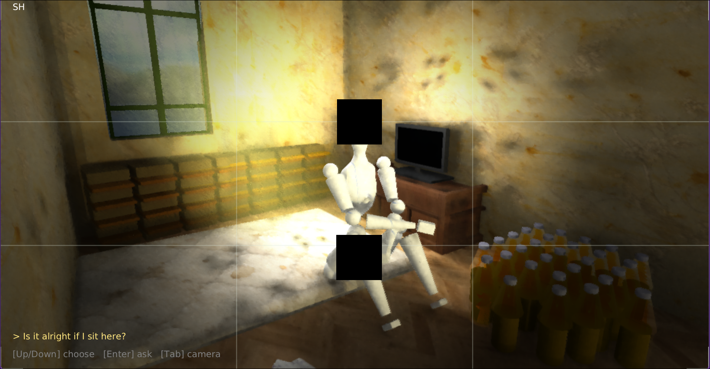

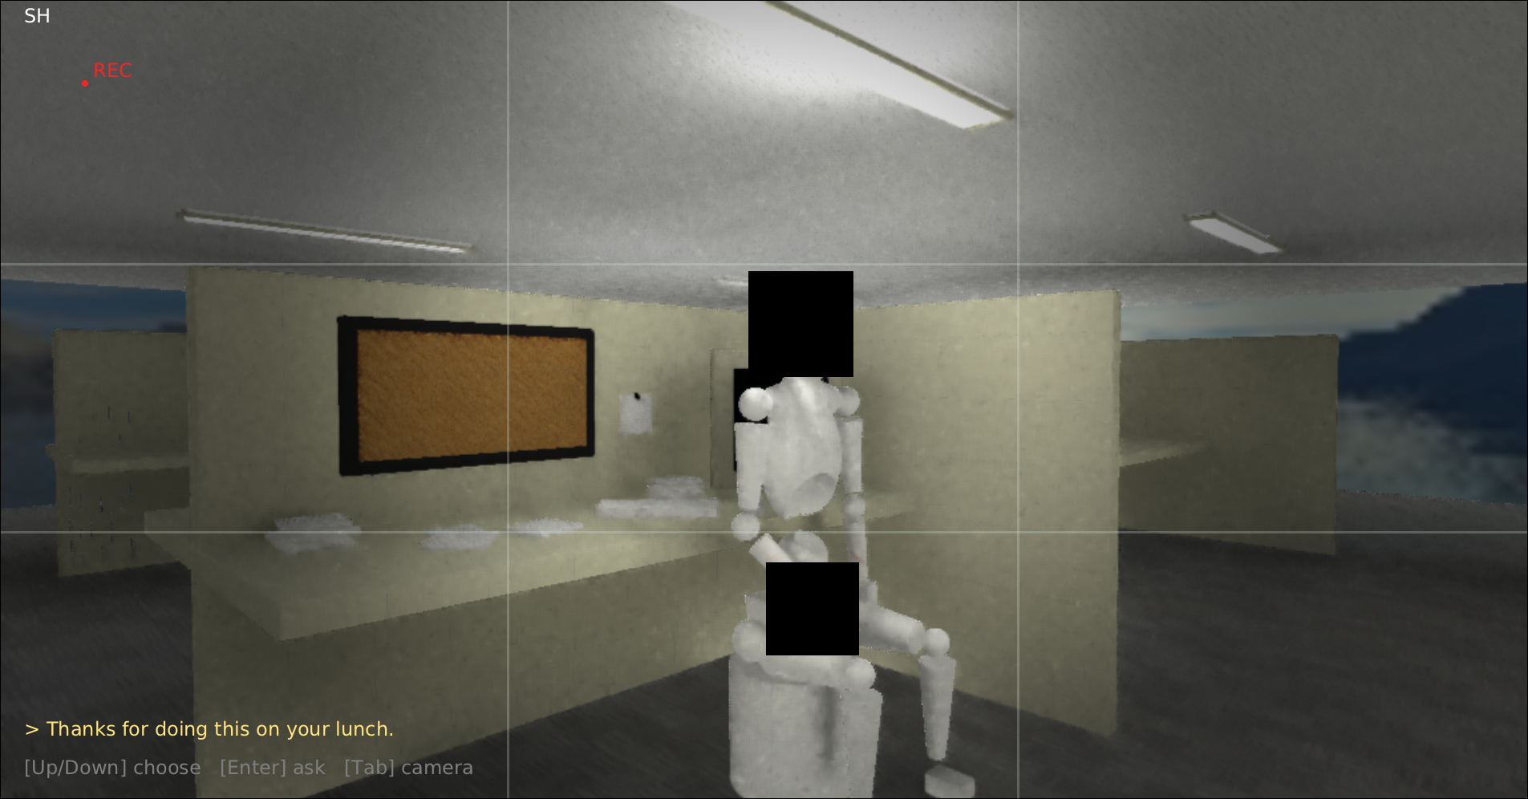
Diego

Theo
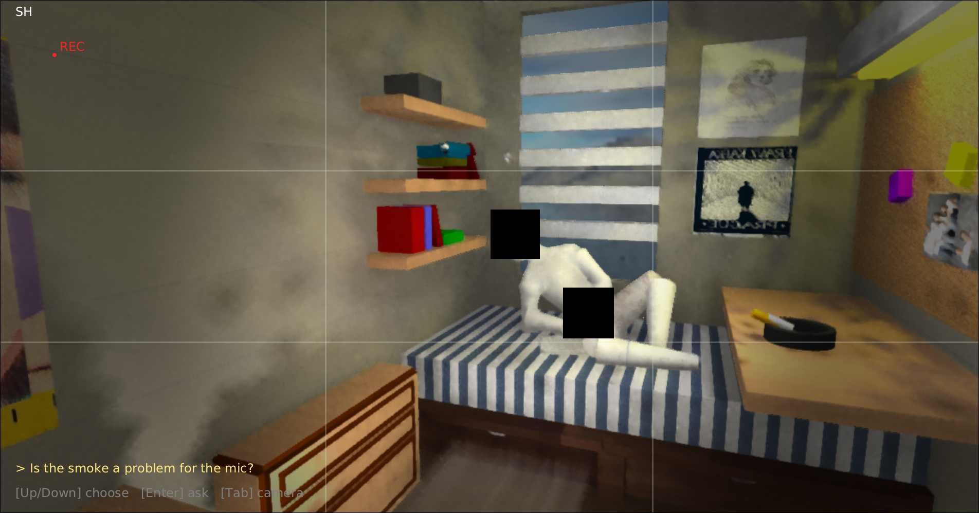

Pat

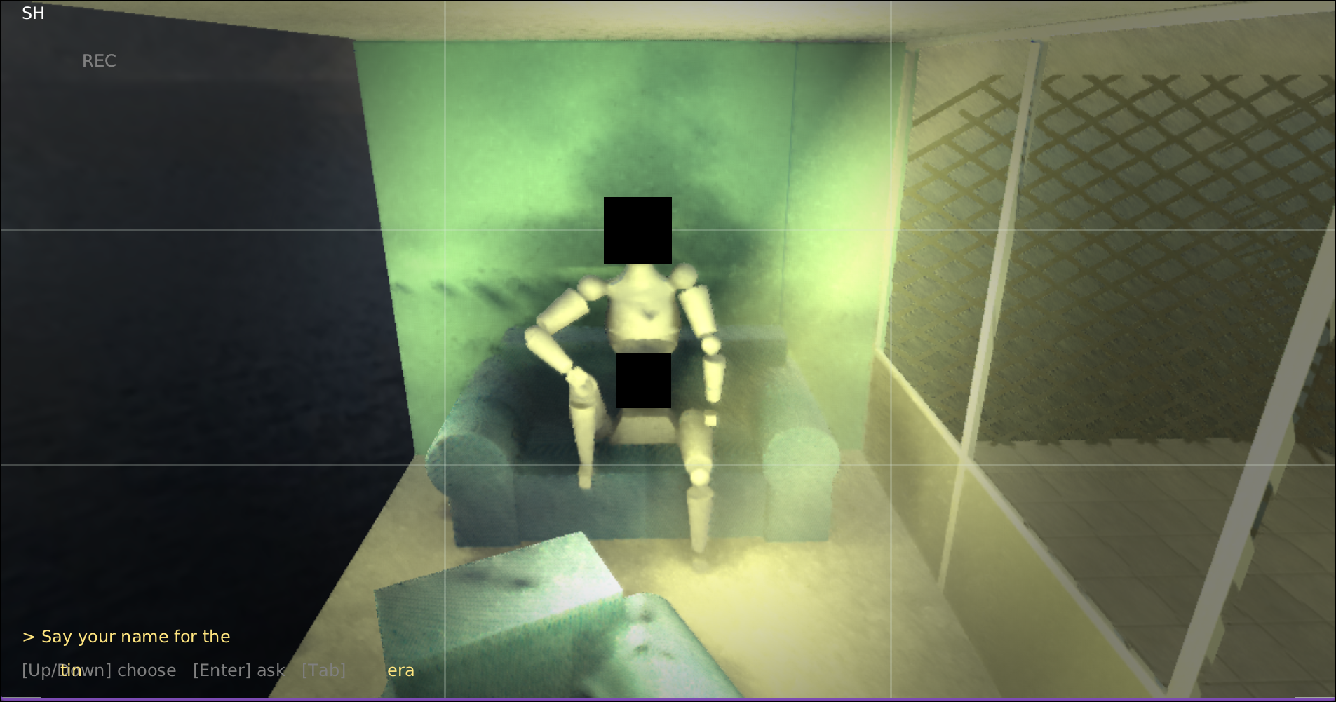
Theresa
`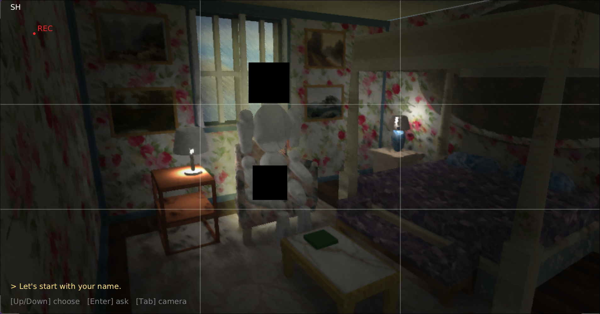

Alex

